Getting started

raspi-config

New “Administrator” user and password

Boot into Gui

Handy Hints

Setting up WiFi

Setting up WiFi from application (wpa_gui)

Setting up WiFi from command line (wpa_supplicant.conf)

Setting up Multiple Raspberry Pi’s

Give your pi a static ip address

DHCP+NAT

## 

## 

## **Getting Started**

### Setting up the hardware

Let’s begin by setting up the hardware of one raspberry pi! For this part of the tutorial, you will need a

* Raspberry Pi
* Micro-USB cable
* HDMI cable
* Ethernet cable
* USB keyboard
* Mouse

First, let us begin with the raspberry pi. The picture on the left is what the raspberry pi will initially look like and the picture on the right is the targeted end result.

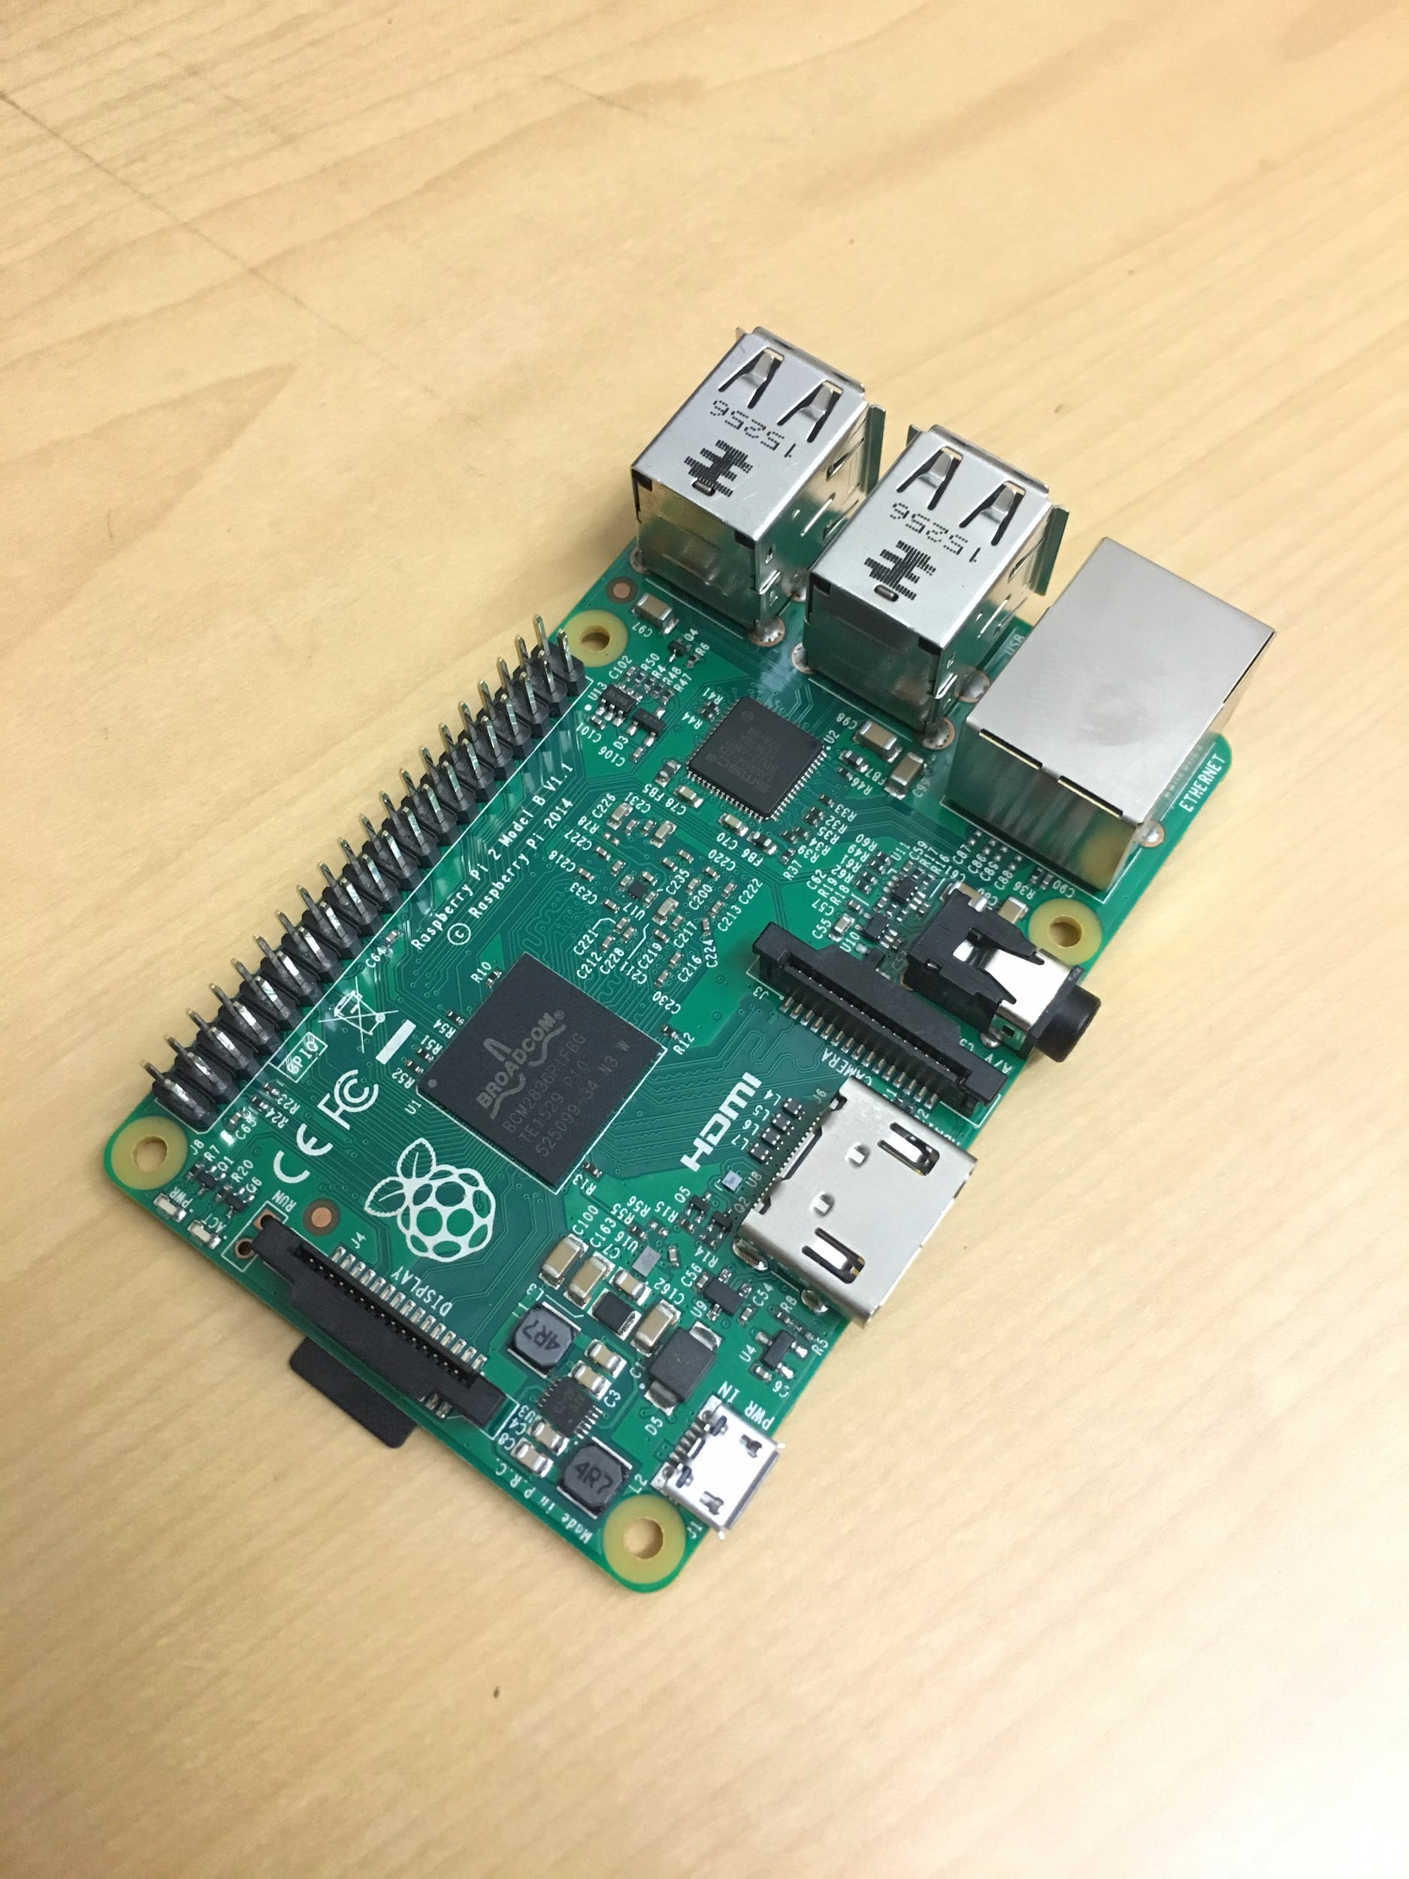 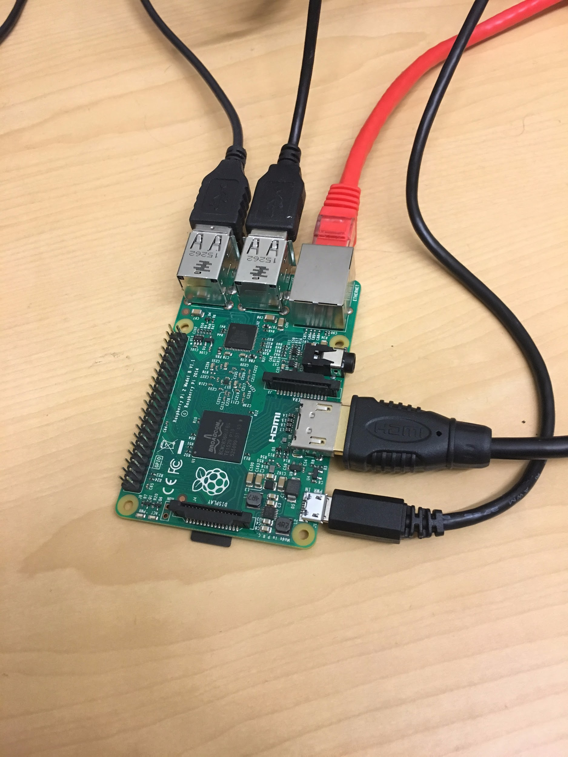

Ensure that the micro SD card is inserted into the Raspberry Pi. If not, insert the card now.

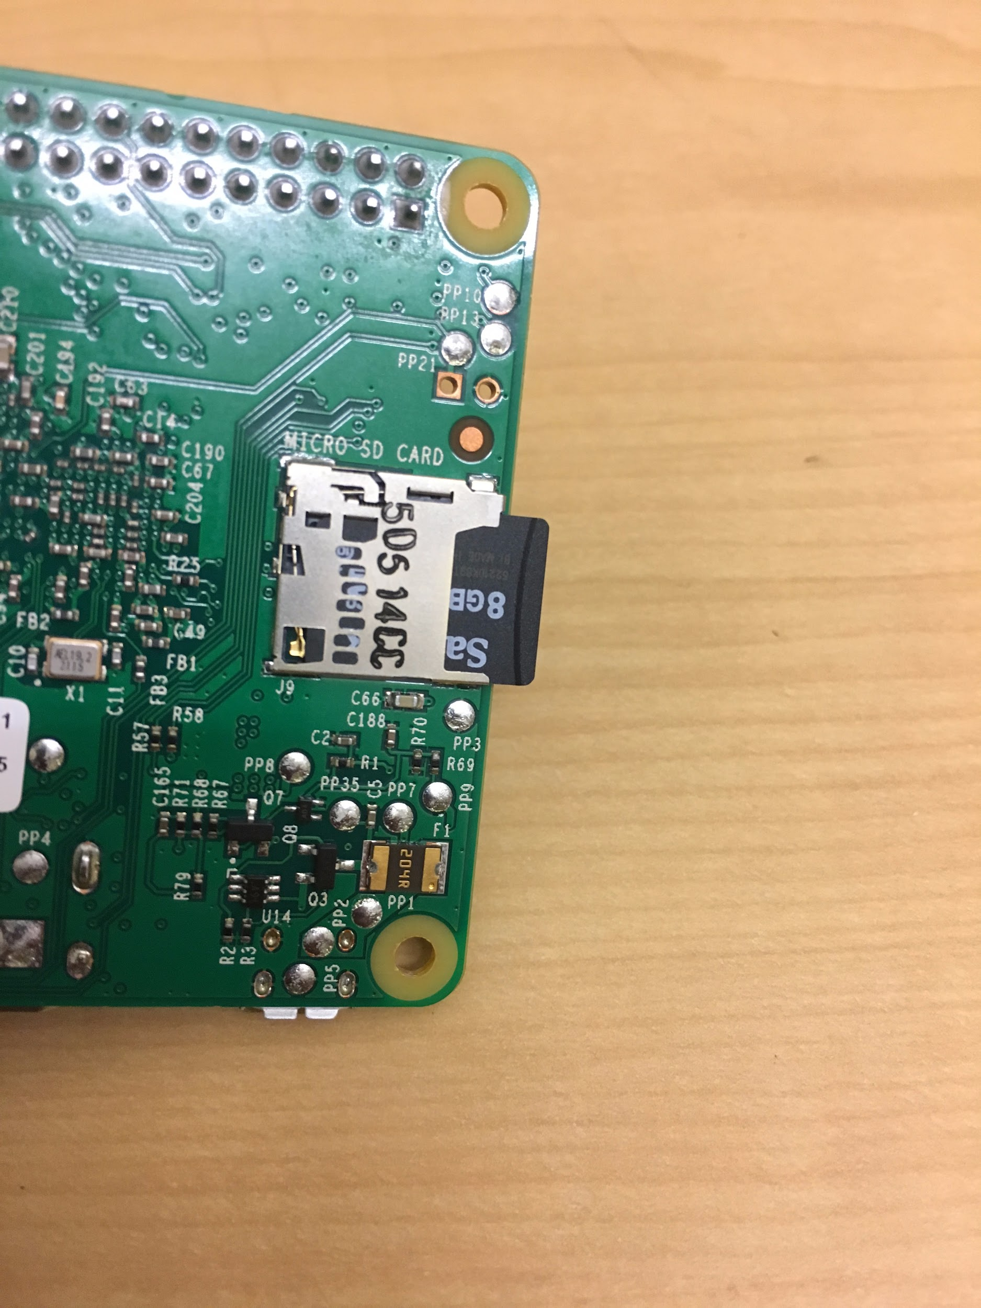

Next, connect the HDMI cable to the Raspberry Pi. Insert the cable into the slot provided on the chip as seen below.

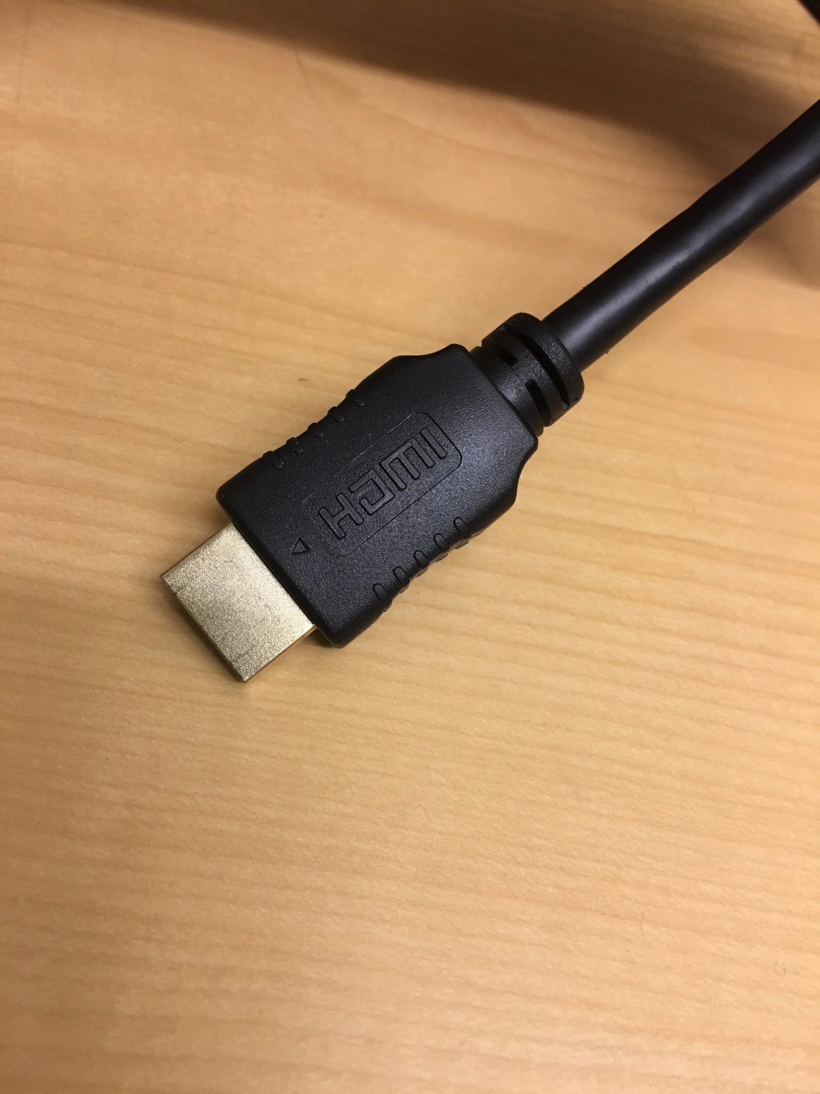 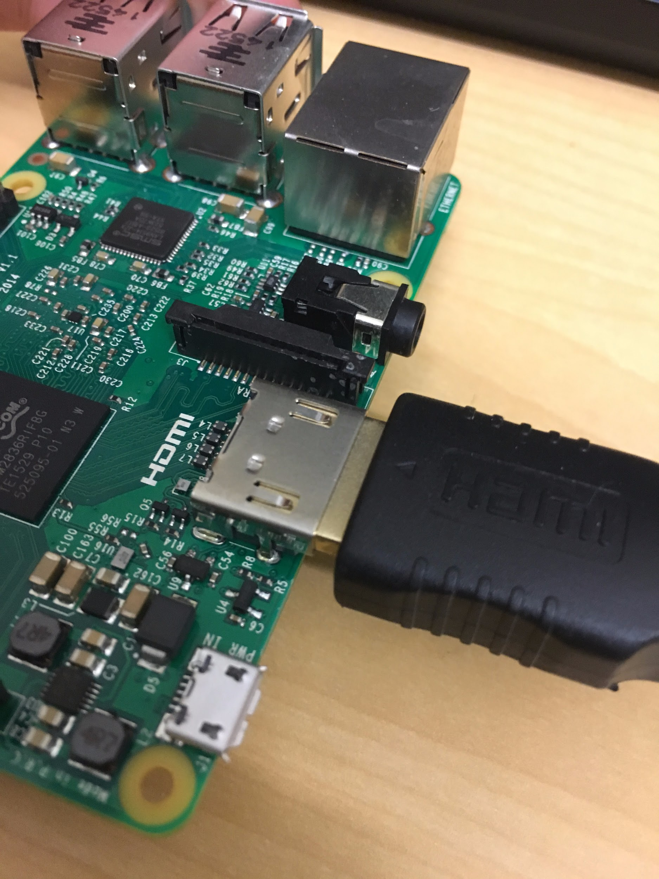

HDMI cable The cable inserted into the pi

Connect the Ethernet cable to the Raspberry Pi.

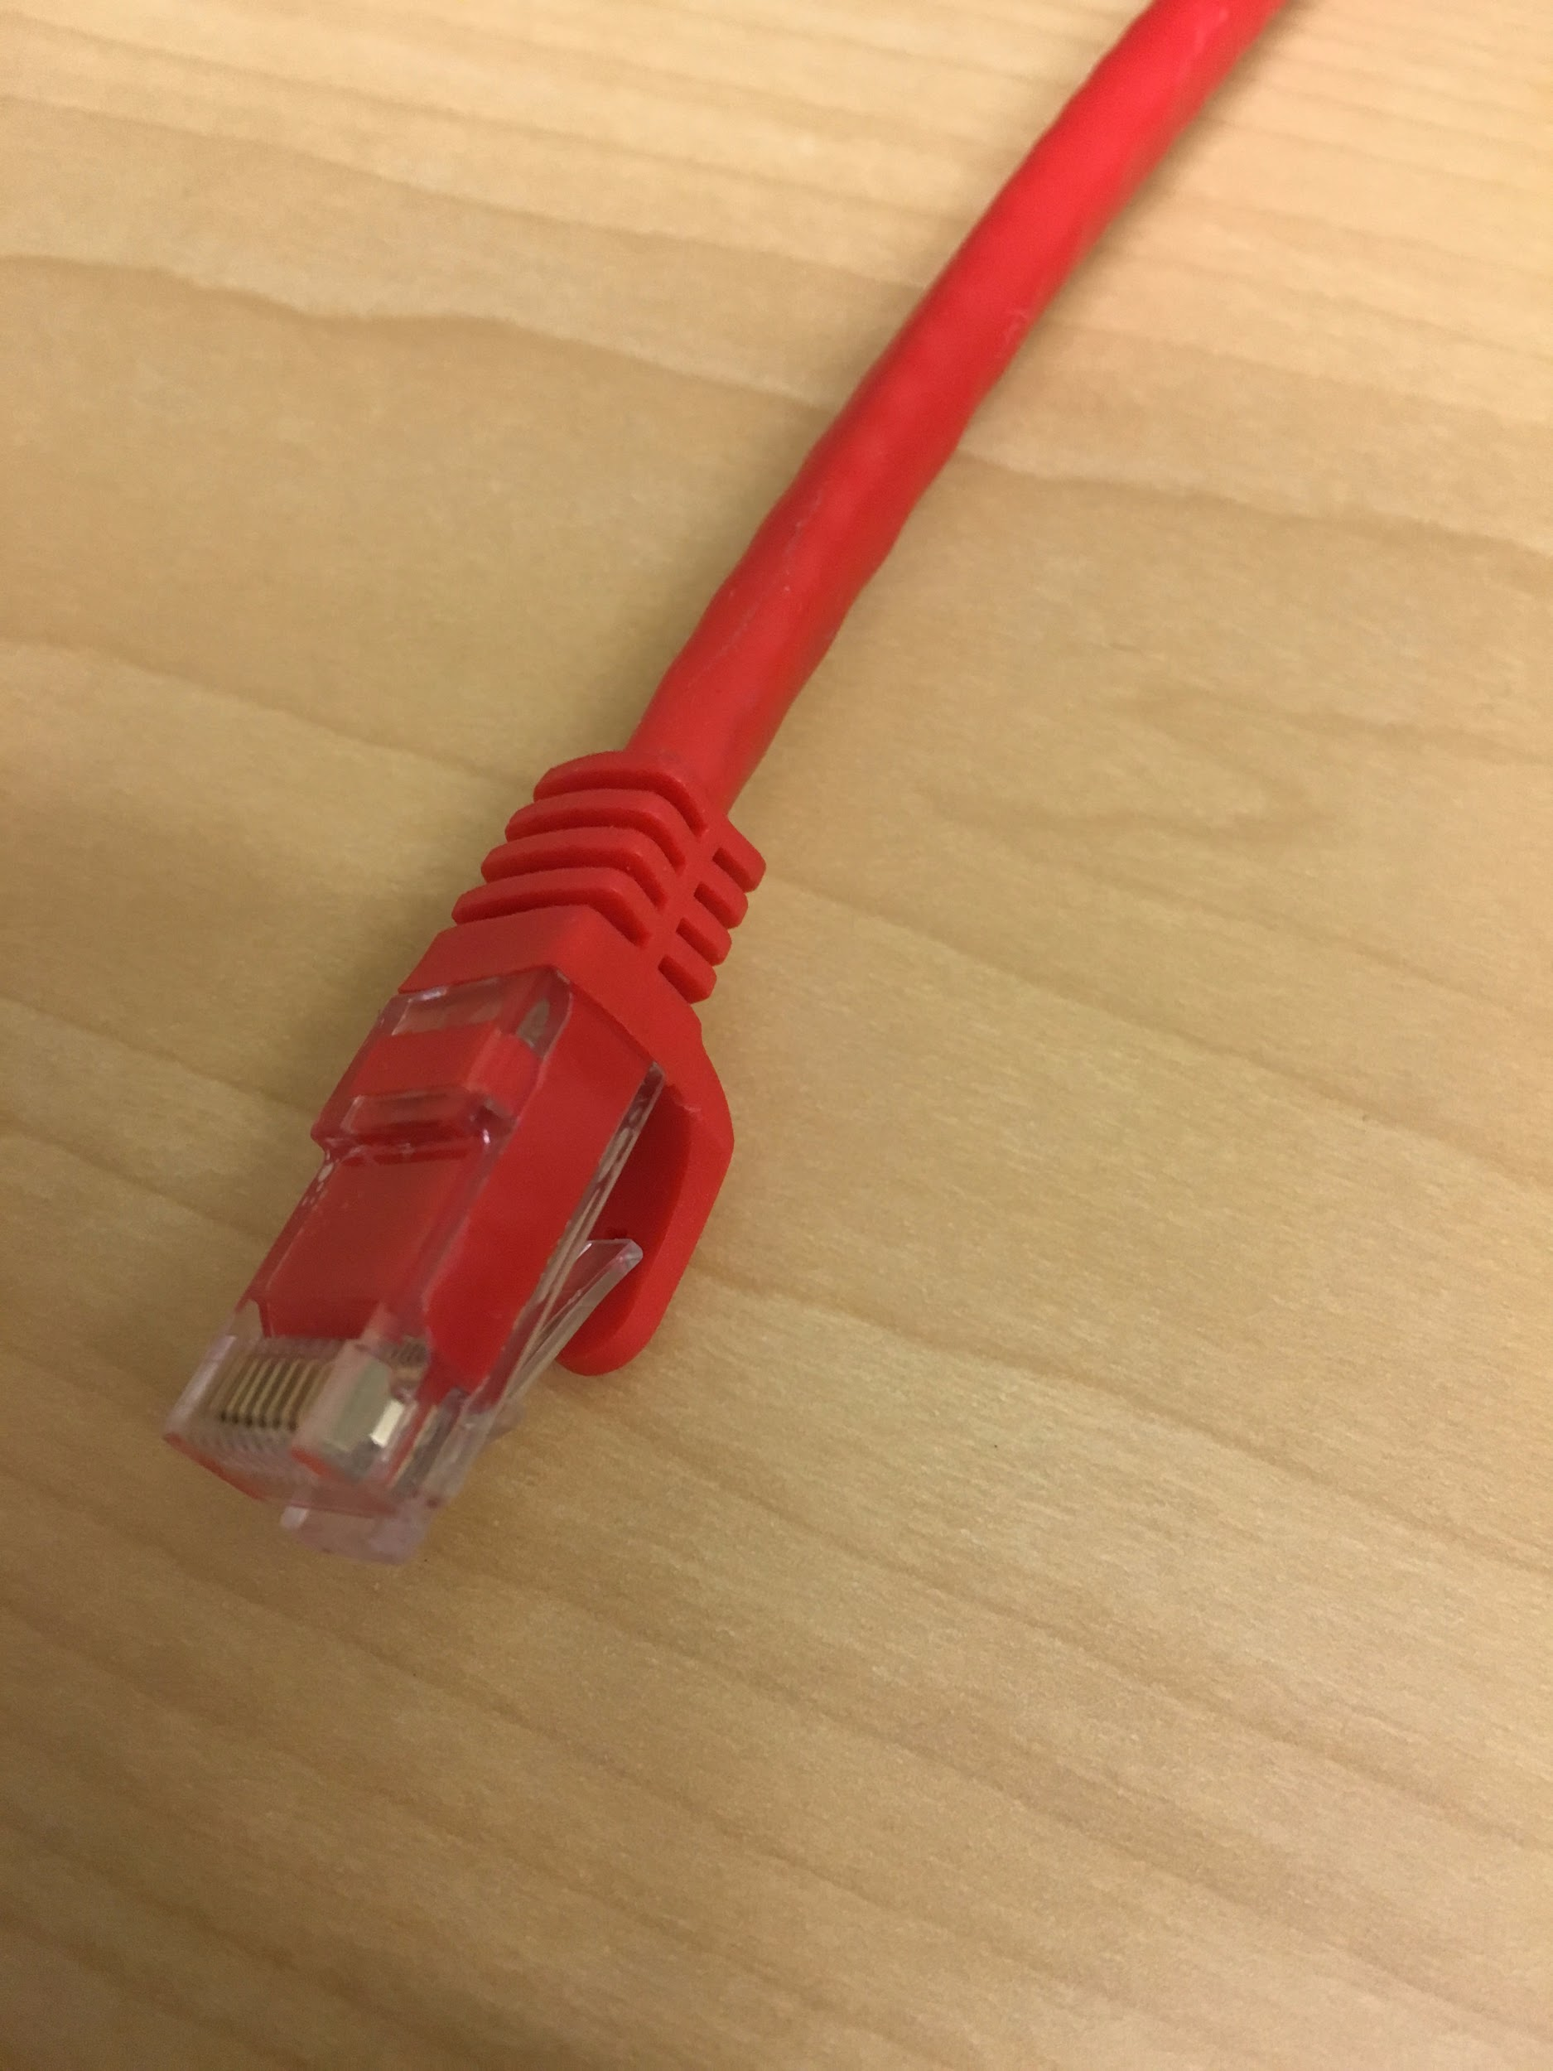 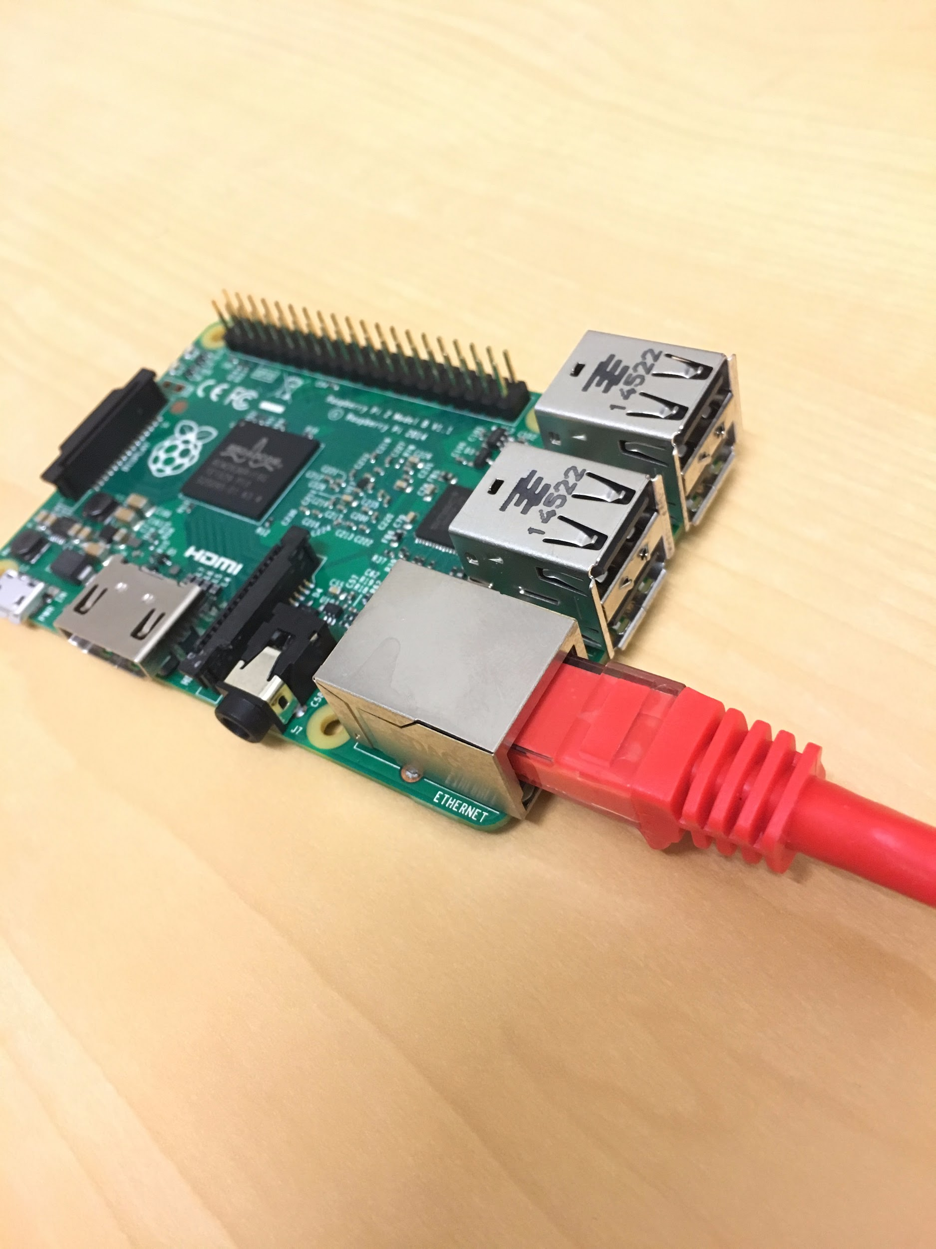

Ethernet cable The cable inserted into the pi

After connecting the Ethernet cable,connect the mouse and keyboard via USB. Both of these cables can be plugged into any of the four USB slots on the Raspberry Pi.

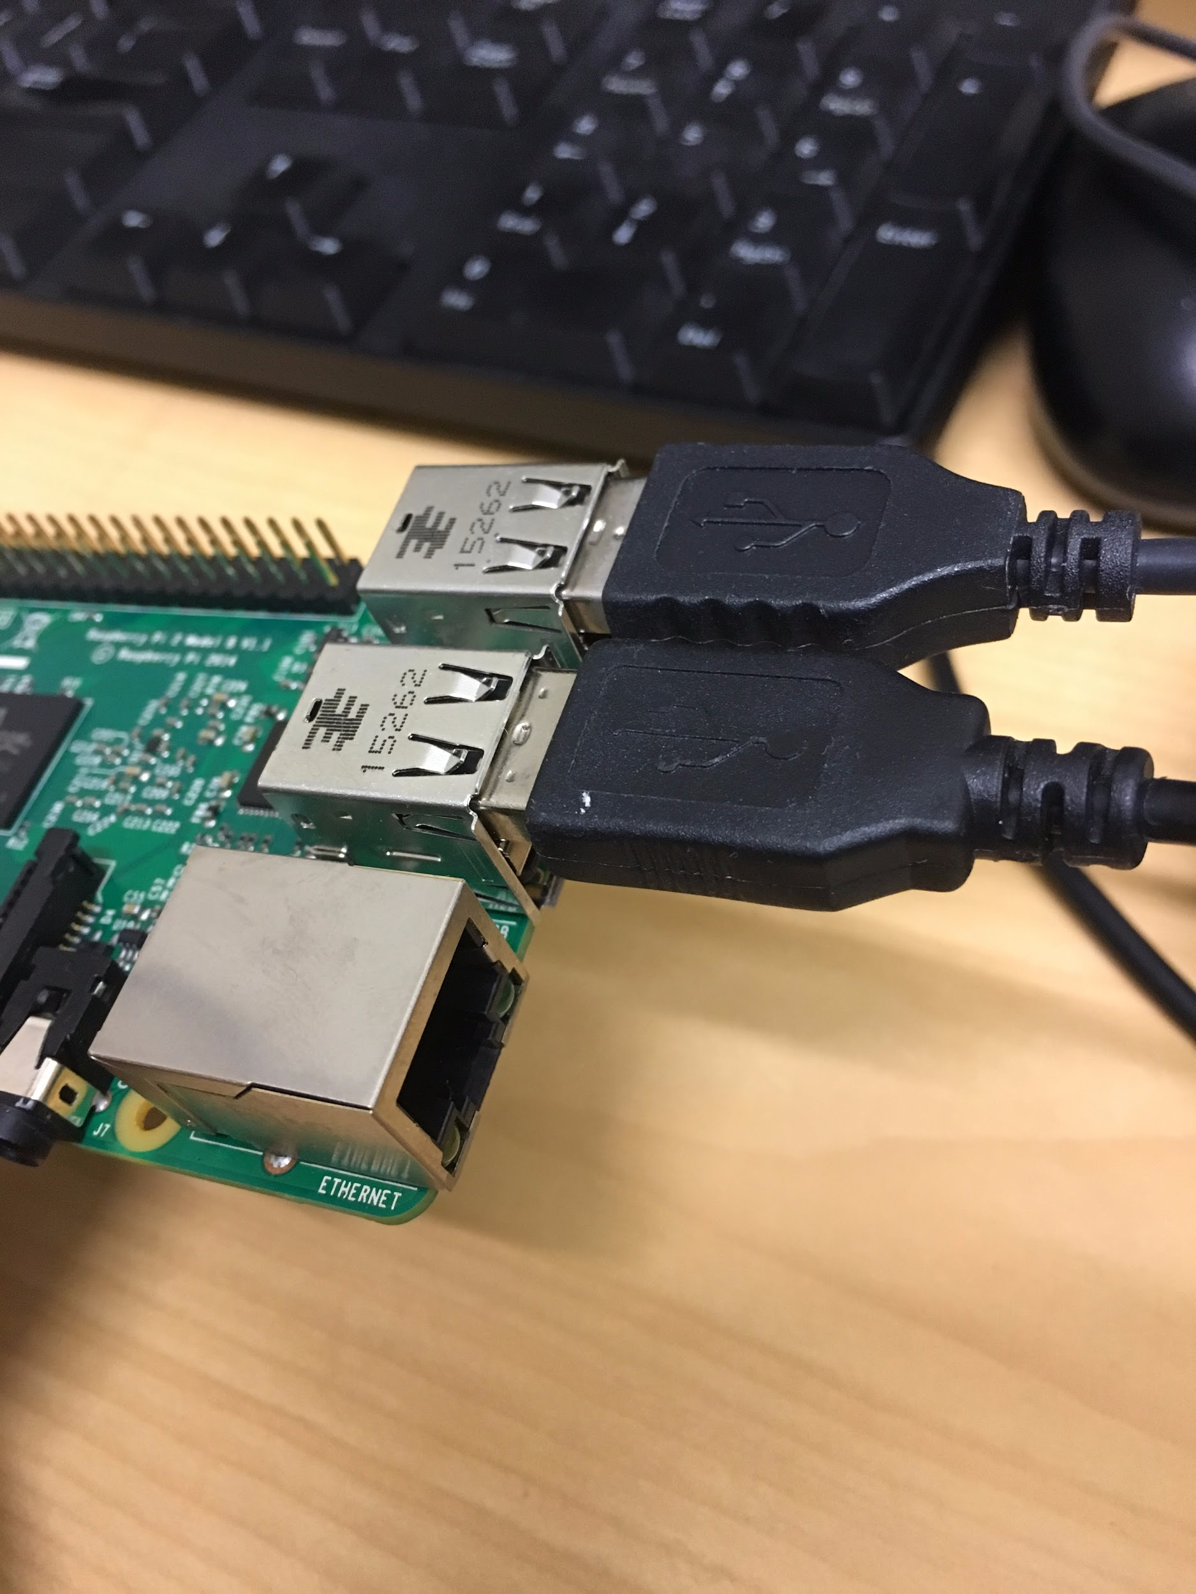

Finally, we will connect the power! Connect the micro usb cable to the raspberry pi as shown below. The raspberry pi will turn on the instant you connect it to power, and now you should be able to see the computer booting up on the display.

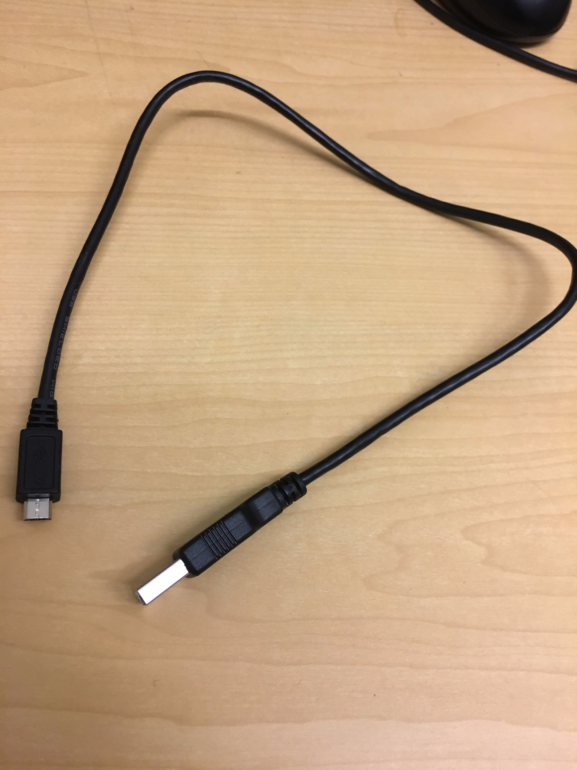 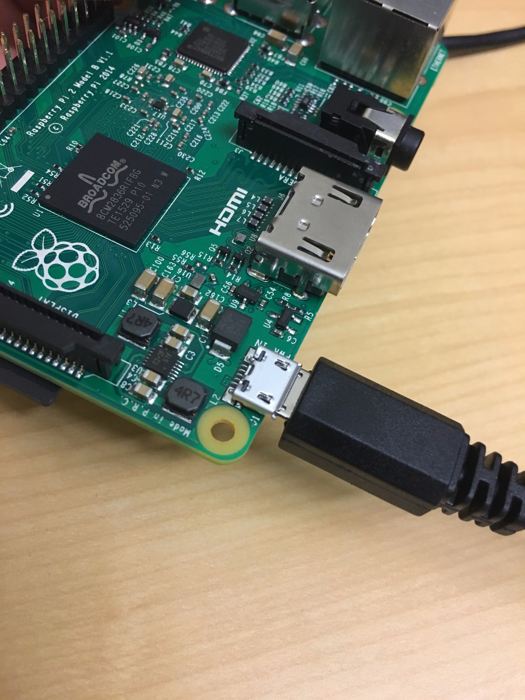

### raspi-config

At this point, you have your raspberry pi. You’ve connected a USB mouse, a USB keyboard, and an HDMI cable to your monitor. You also have the minimum outlets you need to power your RPi and monitor. Now here’s the fun part: turn your RPi on!

After a while, you’ll get this blue screen with a grey window that has red highlighted text. This is raspi-config (“Raspberry Pi Configure”), and as the name implies, we’re going to use it to configure some options. Move to options with the keyboard keys, select with enter button. After each selection you will return to the raspi-config screen, so you should be able to follow the instructions as is. If you go to the wrong step, press the “Escape” key once to go back. Do the following:

* Move to “2 Change User Password” and select, then select <Ok> to confirm, and finally enter password by typing on the keyboard. If your enter your password incorrectly, or it says there was an error, redo this step.
  + The password we’ll be using is “sandiegosupercomputercenter”
* Move to “3 Enable Boot to Desktop/Scratch” and select, then move to “Desktop Log in as user ‘pi’ at the graphical desktop’ and select
* Move to “4 Internationalisation Options” and select. Then select “I1 Change Locale”. Move down to “en_GB.UTF-8 UTF-8” and dehighlight (press SPACEBAR), then move down to “en_US.UTF-8 UTF-8” and highlight (press SPACEBAR). Then press “ENTER”. Then move down to select “en_US.UTF-8” and press “ENTER”.
* Move to “4 Internationalisation Options” (again) and select. Move down to “I2 Change Timezon” and select. Move up to “US” and select. Move up to “Pacific Ocean” and select.
* Move to “4 Internationalisation Options” (again) and select. Move down to “I3 Change Keyboard Layout” and select. Select the currently highlighted keyboard. Move down to “Other” and select. Move down to “English (US)” and select. Move up to “English (US)” and select. Select the currently highlighted defaults until back at raspi-config.
* Move to “8 Advanced Options” and select, then select “A1 Overscan”, then move to “<Enable>” and select
* Move to “8 Advanced Options” and select, then move to “A4 SSH” and select, then select “<Enable>”
* Move to “8 Advanced Options” and select, then move to “A2 Hostname” and select, select to confirm, then delete the current hostname and enter “pinode0” and select to confirm.
* Move to “<Finish>” (Right Arrow + Right Arrow) and select

### New “Administrator” user and password <---- DONT DO THIS ANYMORE

At this point, you can turn your Raspberry Pi on and be automatically logged in to the default Raspberry Pi user, *pi*. Now we want to add another user with a password.

1. Open your terminal (black screen monitor icon in top taskbar) to access the command line
2. Enter “sudo adduser piNode# --force-badname” (for the chosen # number) at the command line, and set the password to “sandiegosupercomputercenter”. Press “ENTER” for all other inputs until the last input. Press “Y” and then “ENTER” to confirm.
3. Enter “sudo visudo”, go to the bottom of the file (“DOWN arrow key”), and then change the line “pi ALL=(ALL) NOPASSWD: ALL” to “piNode# ALL=(ALL) NOPASSWD:ALL”.
4. Note: If you need to change an account’s password for whatever reason, enter “sudo passwd ACCOUNT_NAME”, where ACCOUNT_NAME is the account name of the account to be changed (if you’re logged in to the account you want to change, the terminal command “whoami” will display your account name / user name.

### Boot into Gui <----- DONT DO THIS ANYMORE

At this point, you can turn your Raspberry Pi on and be automatically logged in to the default Raspberry Pi user, *pi*. *pi* now also has a password, and there is another user already added, *piNode#*. At this point we’re going to have the Raspberry Pi boot from your new super user *piNode#*.

1. Open terminal
2. Write to the raspi-config file by entering “sudo nano /usr/bin/raspi-config”
3. First search part of file needed to be changed. With nano, to search, enter CTRL+W; then enter “do_boot_behaviour” as the string to search for.
4. Follow these commands to edit the necessary raspi-config lines
   1. Set raspi-config default “*pi*” username to “*piNode#*” for some *#* (starting at 0)

“Desktop” “Log in as user ‘pi’ at the graphical desktop” \

->

“Desktop” “Log in as user ‘piNode#’ at the graphical desktop”

* 1. Set default “*pi*” username to “*piNode#*” for some *#* (starting at 0)

if id -u pi > /dev/null 2>&1; then ->

if id -u piNode# > /dev/null 2>&1; then

* 1. Set error message in case of error

whiptail --msgbox “The pi user has been removed, can’t set up boot to desktop” 20 602 ->

whiptail --msgbox “The piNode# user has been removed, can’t set up boot to desktop” 20 602

* 1. Set autologin to the new username

sed /etc/lightdm/lightdm.conf -i -e “s/^#autologin-user=.*/autologin-user=pi/” ->

sed /etc/lightdm/lightdm.conf -i -e “s/^#autologin-user=.*/autologin-user=piNode#/”

* 1. Set default username for boot by Scratch

if id -u pi > /dev/null 2>&1; then ->

if id -u piNode# > /dev/null 2>&1; then

* 1. Set error message in case of error for boot by Scratch
     1. whiptail --msgbox “The pi user has been removed, can’t set up boot to desktop” 20 602 ->
     2. whiptail --msgbox “The piNode# user has been removed, can’t set up boot to desktop” 20 602

1. Exit the nano editor by entering “CTRL+O”, then “ENTER”, then “CTRL+X”
2. Write to the lightdm.conf file by entering (on the command line) “sudo nano /etc/lightdm/lightdm.conf
3. First search for “pi” (CTRL+W then enter “pi”), then change “pi” to “piNode#”, and then exit
4. If you want, reboot to verify the changes you made (enter “sudo reboot” at the command line”

## Handy Hints

Note! If you see “unable to resolve host raspberry pi”, do not change the sudoers group until this is resolved; otherwise before switching between users, change the sudoers group, then su immediately

ifconfig wlan0: display ifconfig information on another terminal

netstat -nr: display netstat information on the extra terminal

Note! If manually resolving multiple sudoers error, if root “doesn’t load because file already exists”, make sure to close all preexisting windows from past drives

Note! Remove a user: sudo userdel -r <username>

Note! ssh-copy-id copies local rsa pub key to remote machine

Note! confirming “Are you sure you want to continue connecting” adds to knwon_hosts

Note! authorized_keys gives the permission to the listed remote host to enter this host

Note! Restart network: either reboot “sudo shutdown -r now” or “sudo /etc/init.d/networking restart”

Note! If you restart the networking interface and also use “allow-hotplug”, the interface may not restart with “/etc/init.d/networking/restart” and might just be left “down”

## 

## 

## Setting up WiFi

### Setting up WiFi from application (wpa_gui)

Go to: Menu->Preferences->Wifi Configuration (opens a program called wpa_gui; icon is a black square with concentric white rings)

If you already inserted the wifi adapter into the USB port, check the "Adapter: " field to see if there is a network option available (the drop down menu will list at least one option). There is no network option available if it is blank, white'd out, blue'd out, or the field is "selected" but nothing is showing. In this case, physically disconnect the adapter and then physically reconnect it. This will generally cause the application to recognize the adapter. <What to do if it does not?>

If you did not already insert the wifi adapter into the USB port, do so now. Wait for the wpa_gui application window's "Adapter: " field to change to a type of network (e.g. wlan0). <What to do if it does not?>

Once the adapter is recognized (the "Adapter: " field will show an option (e.g. wlan0)) then go to Network->Add. Type the name of the network you want to connect to (e.g. SDSC) into the topmost field named "SSID" (Service Set Identifier). If the network you want to connect to requires authentication, select the authentication type in the "Authentication" drop down menu, then enter the required information into the correct field. Once finished, select "Add" to add this network to the application.

At this point, with the correct network credentials entered, the application should automatically configure and connect to the added network. If the "Current Status" tab does not show a "Status: " of either "Completed" or "Connected", then select "Connect" at the bottom of the application to connect. <What to do if it does not?>

### Setting up WiFi from command line (wpa_supplicant.conf)

Setting up WiFi from command line (wpa_supplicant.conf)

1) Open terminal (once logged in to the desktop, select the icon of the computer monitor in the opening screen taskbar; if not in desktop mode, type the commands as regular (make sure to type commands as they are exactly, backspace any letters/characters that don't match))

2) To list possible WiFi networks and their protocols, enter: sudo iwlist wlan0 scan | grep ESSID\|IEEE

3) To configure your network information, enter: sudo nano /etc/wpa_supplicant/wpa_supplicant.conf

4) If your network has a password, add the following to the end of the file:

network={

ssid="ESSID"

psk="password"

}

... where ESSID is the ESSID listed in step 2 corresponding to your network, and password is the password corresponding to the network you entered.

4b) If your network has no password, add the following to the end of the file:

network={

ssid="ESSID"

key_mgmt=NONE

auth_alg=OPEN

}

5) To save your edits to wpa_supplicant.conf, since we used the nano editor, press CTRL+O, ENTER, CTRL+X (Write, Confirm, Close).

6) To manually force reconnection "sudo ifdown wlan0" (wait a few seconds for changes to configure network and connect), alternatively enter "sudo reboot" to restart computer

7) To verify wifi connection, enter: "ifconfig wlan0 | grep "inet addr"" into the command line. If nothing is shown, <What to do?>

## Setting up Multiple Raspberry Pi’s

### Give your pi a static ip address

Make sure your network connection is stable (check wpa_gui or enter “ping www.google.com”

cat /etc/network/interfaces: change “iface eth0 inet dhcp” to “iface eth0 inet static”

ifconfig: display ifconfig information on another terminal

netstat -nr: display netstat information on the extra terminal

/etc/network/interfaces : add lines to below “iface eth0 inet static” with the appropriate information from ifconfig’s wlan0 tab (enter ifconfig wlan0)

address 10.0.0.#<----- Change to your private ip address (10.0.0.#)

netmask 255.255.255.0 <-------- Change to the value of Mask: ###.###.###.###

network 132.249.64.0 <-------- Change to the (non 0.0.0.0) value under “Destination”

broadcast 132.249.65.255 <-------- Change to the value of Bcast:###.###.###.###

gateway 132.249.64.1 <-------- Change to the (non 0.0.0.0) value under “Gateway”

example:

auto lo

iface lo inet loopback

iface eth0 inet static

address 10.0.0.12

network 255.255.254.0

network 10.0.0.0

broadcast 10.0.1.255

allow-hotplug wan0

iface wlan0 inet manual

wpa-roam /etc/wpa_supplicant/wpa_supplicant.conf

iface default inet dhcp

SAVE

sudo rm /var/lib/dhcp/*

sudo reboot

ifconfig (eth0 should be different)

ping gateway address

ssh-keygen -t rsa

ssh-copy-id piNode#@10.0.0.11

# No Route to host error: MAKE SURE TO REBOOT/RESTART after

### DHCP+NAT

masquerade command “-o wlan0”

etc/network/if-pre-up.d/iptables

address 10.0.0.11

netmask 255.255.254.0

network 10.0.0.0

broadcast 10.0.1.255

gateway 10.0.0.11

route -n

version1:

sudo apt-get install isc-dhcp-server

sudo vim /etc/dhcp/dhcpd.conf Uncomment “authoritative”

subnet 10.0.0.0 netmask 255.255.255.0 {  
range 10.0.0.10 10.0.0.250;  
option broadcast-address 10.0.0.255;  
option routers 10.0.0.10;  
default-lease-time 600;  
max-lease-time 7200;  
option domain-name "local";  
option domain-name-servers 8.8.8.8, 8.8.4.4;  
}

Start dhcp: /usr/sbin/dhcpd

version 2:

<http://www.glennklockwood.com/sysadmin-howtos/rpi-wifi-island.html>

#!/bin/sh

IPT=/sbin/iptables

LOCAL_IFACE=eth0

INET_IFACE=wlan0

INET_ADDRESS=192.168.1.98

# Flush the tables

$IPT -F INPUT $IPT -F OUTPUT $IPT -F FORWARD $IPT -t nat -P PREROUTING ACCEPT $IPT -t nat -P POSTROUTING ACCEPT $IPT -t nat -P OUTPUT ACCEPT

# Allow forwarding packets:

$IPT -A FORWARD -p ALL -i $LOCAL_IFACE -j ACCEPT $IPT -A FORWARD -i $INET_IFACE -m state --state ESTABLISHED,RELATED -j ACCEPT

# Packet masquerading

$IPT -t nat -A POSTROUTING -o $INET_IFACE -j SNAT --to-source $INET_ADDRESS

version -3

sysctl modifies linux kernel parameters

virtual private system, parameter goes away on reboot

/proc, /etc/syctl.conf

specifies interfaces in wlan0, eth0 ::::

/etc/systemconfig. (where should iptables be recorded)?